1. Create metaobject-> custom data->metaobjects
2. 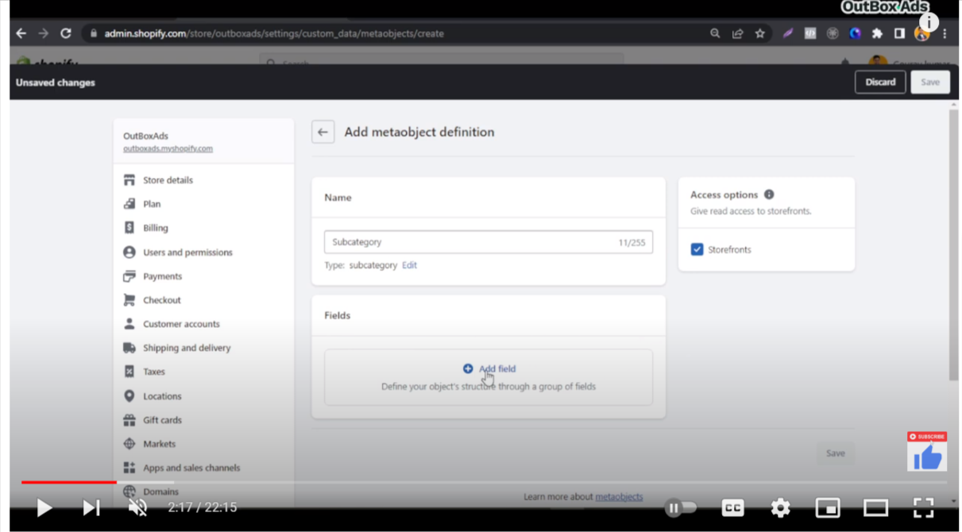
3. Select add field-> single line text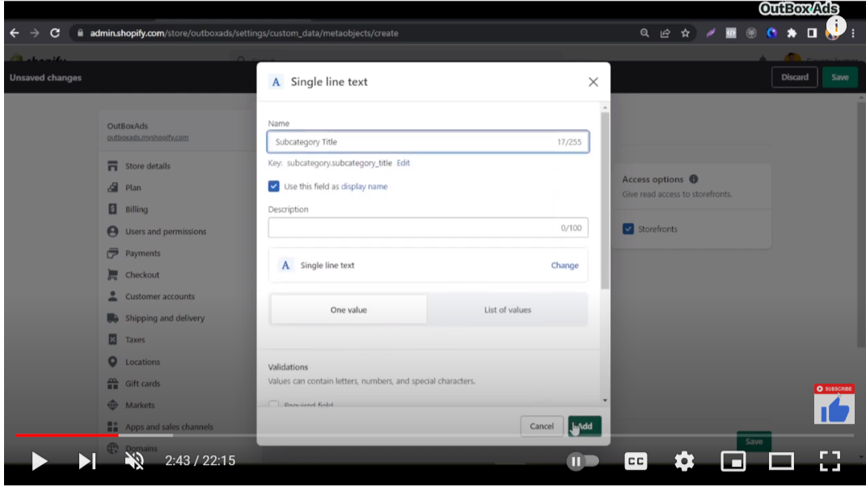
4. Add one value-> click on add button
5. 2nd field ->reference->file :name:subcategory image-> select on value ->images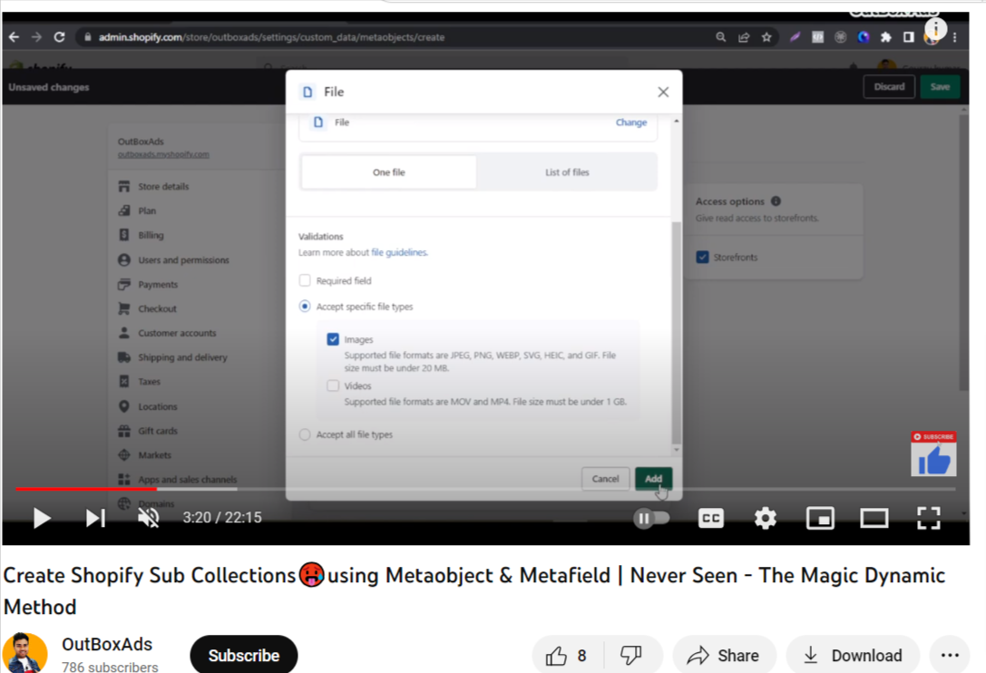
6. Add 3rd field-> subcategory url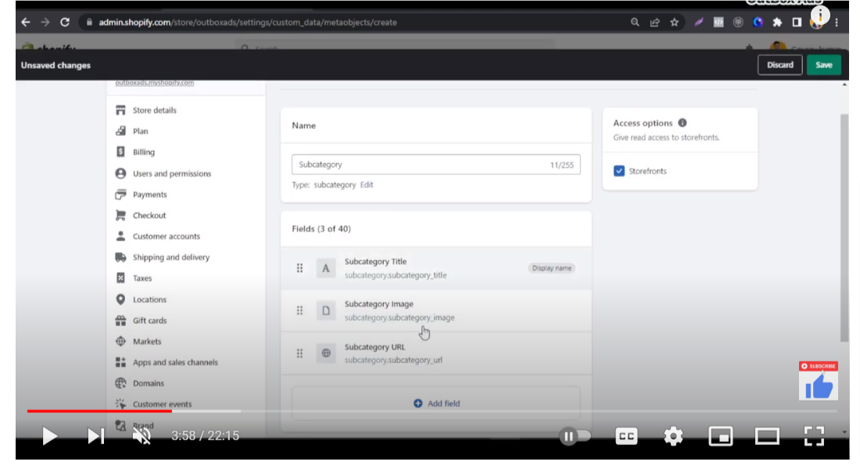



7.add metafields for subcategory metaobjects

1. 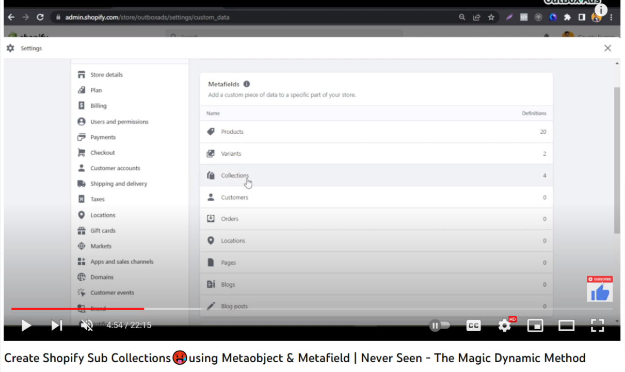
2. Add defination ->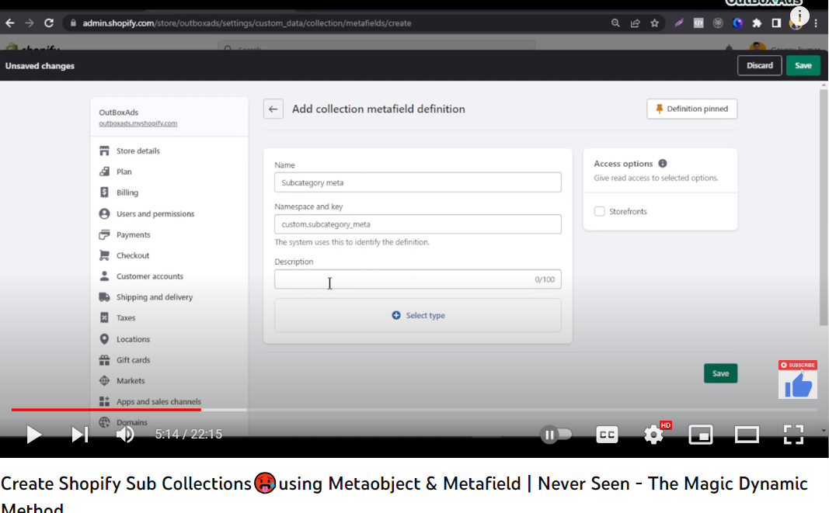
3. Select metaobjects->reference->select metaobjects(subcategory)-> list of entries

**Step 3: Input Data to metaobjects**

1. content -> metaobject
2. 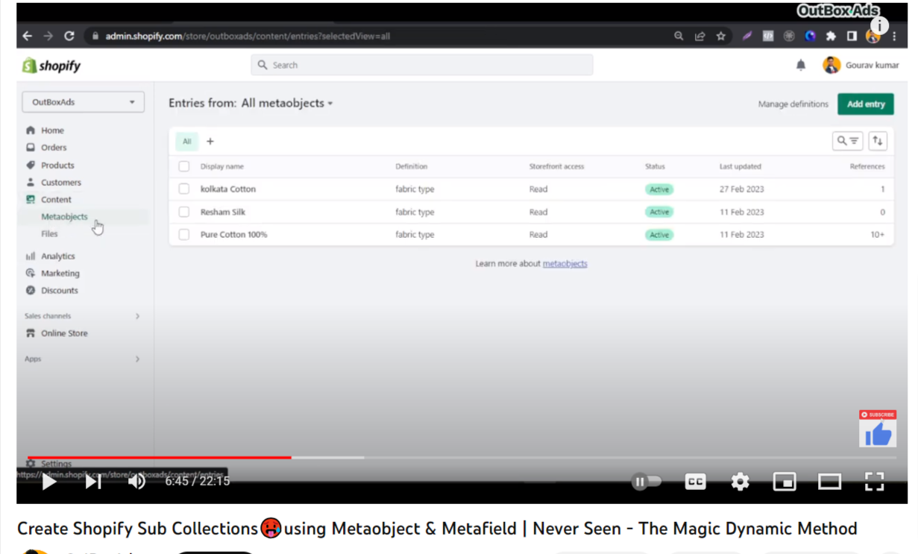
3. Add entry (add subcategories for category)-> subcategory->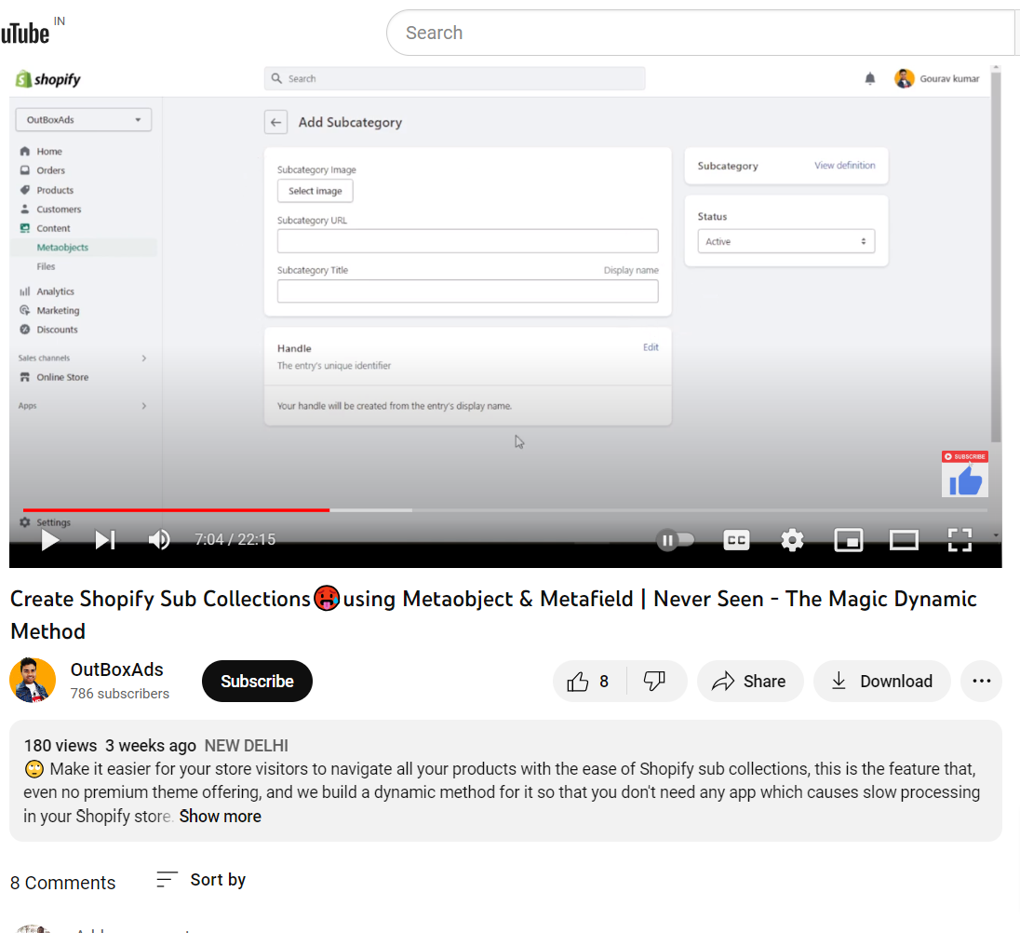
4. Select collecti0n-> add metafield -> select subcategory which you want to show on perticular collection page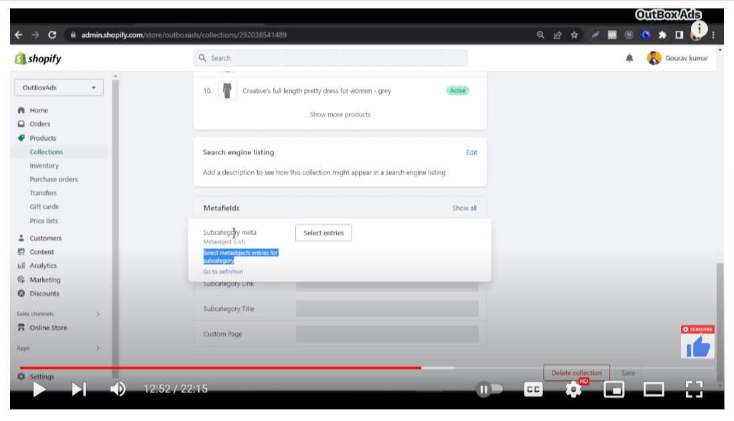
5. Add code file -> subcategory-collection
6. {% style %}
7. div.subcategory-collection {
8. text-align: center;
9. padding:20px 20px;
10. }
11. a img {
12. transition: transform 0.3s;
13. }
14. a:hover img {
15. transform: scale(1.1);
16. }
17. .no-underline {
18. text-decoration: none;
19. }
20. {{ 'Subcatregory-collection.css' | asset_url | stylesheet_tag }}
21. {% endstyle %}
22. {% comment %}
23. {% for block in section.blocks %}
24. {% if block.type == 'Subcategory-block' %}
25. {% assign parent_collection_handle = block.settings.subcategory-image %}
26. {% assign parent_collection = collections[parent_collection_handle] %}
27. {% if parent_collection %}
28. <div class="subcategory-collection">
29. <h2>{{ block.settings.subcategory-title }}</h2>
31. <ul class="subcategory-list">
32. {% for subcollection in parent_collection.collections %}
33. {% assign subcollection_image = subcollection.image %}
34. {% if subcollection_image %}
35. <li class="subcategory-item">
36. <a href="{{ subcollection.url }}">
37. <img src="{{ subcollection_image | img_url: '500x500' }}" alt="{{ subcollection.title }}" width="200" height="200"defer>
38. <span>{{ subcollection.title }}</span>
40. </a>
41. </li>
42. {% endif %}
43. {% endfor %}
44. </ul>
46. </div>
47. {% endif %}
48. {% endif %}
49. {% endfor %}
51. {% if template contains 'collection' %}
52. {% for block in section.blocks %}
53. {% if block.type == 'Subcategory-block' %}
54. {% assign parent_collection_handle = block.settings.subcategory-image %}
55. {% assign parent_collection = collections[parent_collection_handle] %}
56. {% if parent_collection %}
57. <div class="subcategory-collection">
58. <h2>{{ block.settings.subcategory-title }}</h2>
59. <ul class="subcategory-list">
60. {% for subcollection in parent_collection.collections %}
61. {% assign subcollection_image = subcollection.image %}
62. {% if subcollection_image %}
63. <li class="subcategory-item">
64. <a href="{{ subcollection.url }}">
65. <img src="{{ subcollection_image | img_url: '500x500' }}" alt="{{ subcollection.title }}">
66. <span>{{ subcollection.title }}</span>
67. </a>
68. </li>
69. {% endif %}
70. {% endfor %}
71. </ul>
72. </div>
73. {% endif %}
74. {% endif %}
75. {% endfor %}
76. {% else %}
77. {% assign parent_collection_handle = section.blocks[0].settings.subcategory-image %}
78. {% assign parent_collection = collections[parent_collection_handle] %}
79. {% if parent_collection %}
80. <div class="parent-category-collection">
81. <h2>{{ parent_collection.title }}</h2>
82. <ul class="subcategory-list">
83. {% for collection in parent_collection.collections %}
84. {% assign collection_image = collection.image %}
85. {% if collection_image %}
86. <li class="subcategory-item">
87. <a href="{{ collection.url }}">
88. <img src="{{ collection_image | img_url: '500x500' }}" alt="{{ collection.title }}">
89. <span>{{ collection.title }}</span>
90. </a>
91. </li>
92. {% endif %}
93. {% endfor %}
94. </ul>
95. </div>
96. {% endif %}
97. {% endif %}
98. {% endcomment %}
99. <div class="subcategory-collection-section" style="display: flex;justify-content: center;">
100. {% if template contains 'collection' %}
101. {% for block in section.blocks %}
102. {% if block.type == 'Subcategory-block' %}
103. {% assign parent_collection_handle = block.settings.subcategory-image %}
104. {% assign parent_collection = collections[parent_collection_handle] %}
105. {% if parent_collection %}
106. <div class="subcategory-collection">
107. <a href="{{ block.settings.image_link }}" class="no-underline"> <img src="{{ block.settings.subcategory-image | img_url: '50x50' }}" alt="{{ subcollection.title }}"style="border-radius: 50%; border: 4px solid #eee; box-shadow: 0 2px 4px rgba(0, 0, 0, 0.2); ></a>
108. <a href="{{ block.settings.image_link }}"><h3>{{ block.settings.subcategory-title }}</h3></a>
109. <ul class="subcategory-list">
110. {% for subcollection in parent_collection.collections %}
111. {% assign subcollection_image = subcollection.image %}
112. {% if subcollection.image %}
113. <li class="subcategory-item">
114. <a href="{{ subcollection.url }}">
115. <img src="{{ subcollection.image | img_url: '500x500' }}" alt="{{ subcollection.title }}">
116. <span>{{ subcollection.title }}</span>
117. </a>
118. </li>
119. {% endif %}
120. {% endfor %}
121. </ul>
122. </div>
123. {% endif %}
124. {% endif %}
125. {% endfor %}
126. {% else %}
127. {% assign parent_collection_handle = section.blocks[0].settings.subcategory-image %}
128. {% assign parent_collection = collections[parent_collection_handle] %}
129. {% if parent_collection %}
130. <div class="parent-category-collection">
131. <h2>{{ parent_collection.title }}</h2>
132. <ul class="subcategory-list">
133. {% for collection in parent_collection.collections %}
134. {% assign collection_image = collection.image %}
135. {% if collection_image %}
136. <li class="subcategory-item">
137. <a href="{{ collection.url }}">
138. <img src="{{ collection_image | img_url: '500x500' }}" alt="{{ collection.title }}">
139. <span>{{ collection.title }}</span>
140. </a>
141. </li>
142. {% endif %}
143. {% endfor %}
144. </ul>
145. </div>
146. {% endif %}
147. {% endif %}
148. </div>
149. {% schema %}
150. {
151. "name": "Subcategory Collection",
152. "blocks":[
153. {
154. "type":"Subcategory-block",
155. "name":"Subcategory Item",
156. "settings": [
157. {
158. "type": "image_picker",
159. "label": "Parent Collection",
160. "id": "subcategory-image",
161. "info": "Select the parent collection to display subcategories from."
162. },
163. {
164. "type": "url",
165. "label": "image link",
166. "id": "image_link",
168. "info": "Enter the link for the subcategory collections block."
169. },
171. {
172. "type": "text",
173. "label": "Block Title",
174. "id": "subcategory-title",
176. "info": "Enter the title for the subcategory collections block."
177. }
178. ]
179. }
180. ]
181. ,
182. "presets":[
183. {
184. "name":"Subcategory Collection"
185. }
186. ]
187. }
188. {% endschema %}

Add subcategory collection-home code for customize code

{% style %}

div.subcategory-collection {

text-align: center;

padding:20px 20px;

}

a img {

transition: transform 0.3s;

}

a:hover img {

transform: scale(1.1);

}

.no-underline {

text-decoration: none;

}

{{ 'Subcatregory-collection.css' | asset_url | stylesheet_tag }}

{% endstyle %}

<div class="subcategory-collection-section" style="display: flex;justify-content: center;">

{% for block in section.blocks %}

{% if block.type == 'Subcategory-block' %}

{% assign parent_collection_handle = block.settings.subcategory-image %}

{% assign parent_collection = collections[parent_collection_handle] %}

{% if parent_collection %}

<div class="subcategory-collection">

<a href="{{ block.settings.image_link }}" class="no-underline"> <img src="{{ block.settings.subcategory-image | img_url: '50x50' }}" alt="{{ subcollection.title }}"style="border-radius: 50%; border: 4px solid #eee; box-shadow: 0 2px 4px rgba(0, 0, 0, 0.2); ></a>

<a href="{{ block.settings.image_link }}"><h3>{{ block.settings.subcategory-title }}</h3></a>

<ul class="subcategory-list">

{% for subcollection in parent_collection.collections %}

{% assign subcollection_image = subcollection.image %}

{% if subcollection_image %}

<li class="subcategory-item">

<a href="{{ subcollection.url }}">

<img src="{{ subcollection_image | img_url: '500x500' }}" alt="{{ subcollection.title }}" width="200" height="200"defer>

<span>{{ subcollection.title }}</span>

</a>

</li>

{% endif %}

{% endfor %}

</ul>

</div>

{% endif %}

{% endif %}

{% endfor %}

</div>

{% schema %}

{

"name": "Subcategor home",

"blocks":[

{

"type":"Subcategory-block",

"name":"Subcategory Item",

"settings": [

{

"type": "image_picker",

"label": "Parent Collection",

"id": "subcategory-image",

"info": "Select the parent collection to display subcategories from."

},

{

"type": "url",

"label": "image link",

"id": "image_link",

"info": "Enter the link for the subcategory collections block."

},

{

"type": "text",

"label": "Block Title",

"id": "subcategory-title",

"info": "Enter the title for the subcategory collections block."

}

]

}

]

,

"presets":[

{

"name":"Subcategory Collection home"

}

]

}

{% endschema %}